Financial modelling note: shared ownership
Author: Simon Gill, simon@energylandscape.co.uk
Date: May 2026
This note summarises modelling undertaken by Dr. Simon Gill on behalf of Regen to support the project ‘Investigating shared ownership to fund community climate action through the Climate Hubs’

Introduction

Objective of the project
ClimateHubs have asked Regen to lead a project exploring the potential for shared ownership (SO) of renewable generation to provide future funding for the ClimateHubs programme. For the purposes of this project, shared ownership means a not-for-profit organisation acquiring an equity stake in a generation asset.

Objective of the modelling
The financial modelling element of the project aims to illustrate the potential monetary flows that could accrue to ClimateHubs from an investment in renewable generation made in the next few years.
Note that the modelling is illustrative and is based on typical projects using the assumptions set out below.
The modelling covers both the commercial and the SO perspectives and will be based on a cash flow model developed as an open-source asset by Simon Gill for Regen in 2025.
Where possible, the modelling uses publicly citable data and supplements that with data that is justifiable and aligned with The Energy Landscape and Regen’s understanding of the current investment and operational landscape for offshore wind.
The modelling will provide base cases together with sensitivities covering upside and downside outcomes and showing the impact of important parameters. In doing so, it will highlight both the opportunity and the risks involved in shared ownership.
To reiterate: The modelling is illustrative rather than definitive and is intended to indicate scale and key drivers rather than provide precise estimates.

Phase 1 modelling
The Phase 1 modelling focuses on a 1,000 MW offshore wind farm, typical of the scale of projects currently in development. It assumes an SO organisation buys into a commercial project. Two examples are considered: one where the wind farm has no project-level debt (i.e. it is balance sheet funded), and one where the developers use commercial loans to leverage the project. Note that a fully balance sheet funded offshore wind farm would be very unusual beyond the development stage of the project, with almost all large-scale wind farms being taken forward by joint ventures with project level debt.
The modelling also includes sensitivities that explore typical risks the investors would seek to understand, for example scenarios in which revenue outturn is lower than expected.

Phase 2 modelling
Phase 2 modelling covers onshore wind and solar and uses example projects of approximately 50 MW.
The onshore wind modelling takes a similar approach to the base case study, covering two examples: one involving a balance sheet funded project, and one involving a project with commercial debt. Sensitivities are used more systematically to illustrate the impact of a range of key factors, including public sector debt interest rates and tenor, as well as commercial debt interest rates.
The solar modelling presents an example of a "split-site" project, where the SO organisation has direct physical ownership of a portion of the assets, rather than holding a share in a joint venture Special Purpose Vehicle (SPV).

Ownership models
There is a key difference between ownership models:
- Joint venture in a balance sheet funded project: a joint venture project implies that the physical asset is owned by a company set up for that specific purpose – an SPV. A balance sheet funded project means that there is no project level debt and it is funded directly from the balance sheet of the parent company. Therefore this model does not include commercial debt at the project level

- Joint venture in a project finance funded project : A project finance approach means using debt to pay for a significant fraction of the capital investment. In renewable development this may be as high as 70%. This approach leverage the equity investment, potentially increasing equity returns, but it also increases risk. Buying into a Project Finance Joint Venture means taking a share of the company which owns both the physical asset and the commercial debt.

- Split-site: this is a physical ownership model in which the SO organisation owns specific physical assets completely separately from the commercial developer. It is an approach that has been used in solar. In this case, the SO organisation is directly responsible for the construction, ongoing O&M, land rental etc. of their part of the project.
Models 1 and 3 represent taking a share in the physical assets of the site, Model 2 represents taking a share of both the physical asset and commercial debt. The cash-flow waterfall, representing the priority by which costs and debt servicing are met are shown in Figure 1.

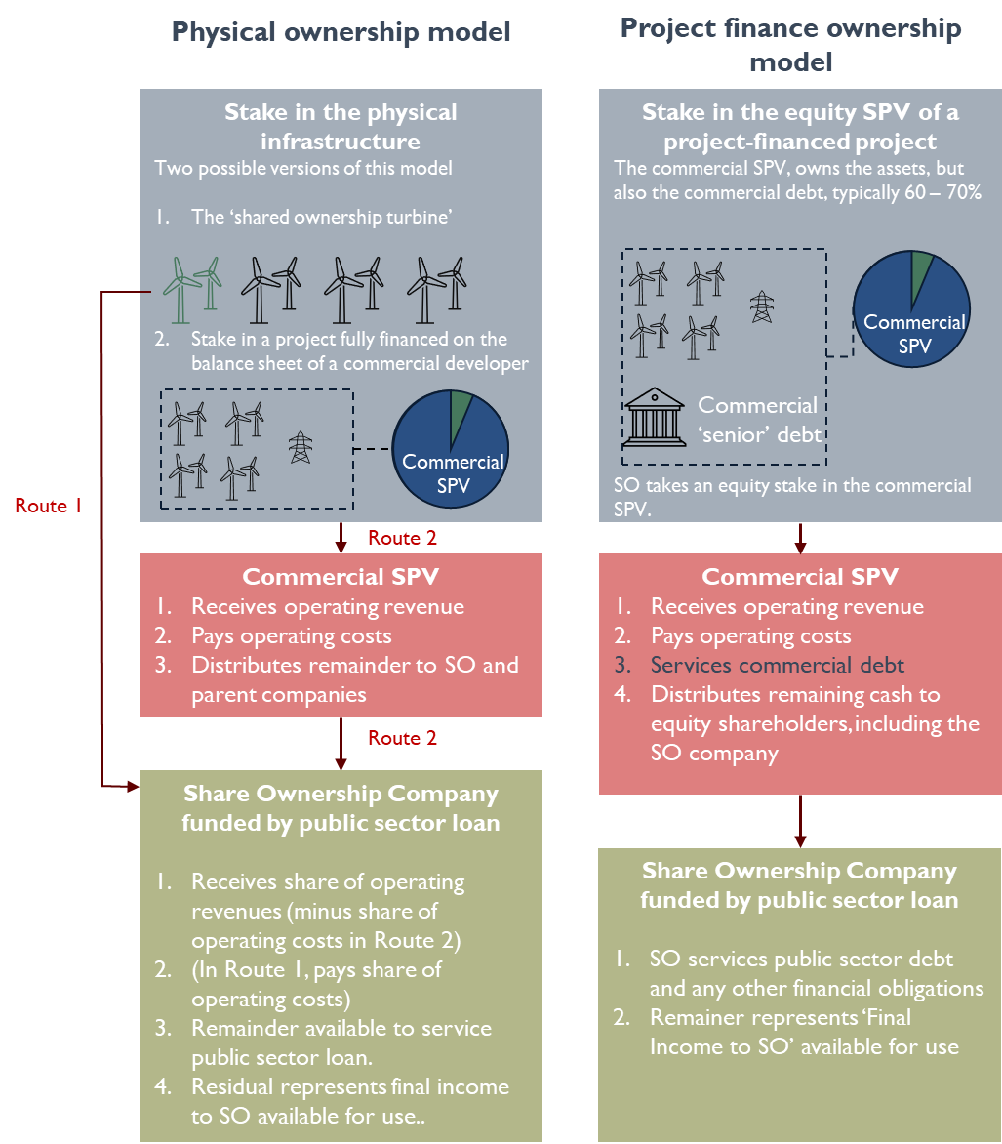
Figure 1: Illustrating different ownership models modelled in this report.

Modelling set up
The example 1,000 MW offshore wind farm project is set in southern Scotland, commissioned in 2028 and operating for 30 years. It assumes an AR6 CfD and a Shared Ownership (SO) Company taking a stake in either the physical asset or the equity of a project-financed joint venture (see Ownership Models below). Shared ownership is assumed to be taken up at Commercial Operations Date (COD). The SO Company is assumed to be financed by a public sector loan over 20 years at interest rates below market levels.
Sensitivities explore TNUoS, operating costs and revenues, public sector loan interest rates, and the option of a public sector grant replacing the loan.

Ownership models
For offshore wind modelling is carried out for ownership models 1 and 2: balance sheet and project-financed joint ventures.

Example project
The example project is a 1,000 MW offshore wind farm, typical of those currently under development in Scotland. It is assumed to be connected in southern Scotland. There are significant variations in the scale of transmission charges faced in different parts of Scotland, which are explored in a sensitivity analysis.

Base case set up
The base case uses an example physical project where costs are based on recent public estimates and revenues are based on a 15-year AR6 contract and strike price, and forecasts of market prices for the merchant tail period (the period following the end of the CfD). Note that AR7 CfD contracts are for 20 years and modelling for projects with an AR7 contract should be adjusted accordingly.
Table 1 sets out the parameters for the overall project. Table 2 sets out the parameters for the commercial debt used in the project-finance ownership model. Table 3 sets out the parameters of the public sector loan assumed to finance the SO Company.

Table 1: key parameters for the example project basecase scenario. Those in grey do not influence the modelling.
Parameter | Basecase | Comment
Capacity | 1,000 MW | Typical Scottish offshore wind project size
Commissioning year | 2028 | Illustrative year only
Price reporting | 2025 real terms | Note most cash flows are given undiscounted. However, discussed cash flows are used for project valuation and Net Present Value calculation where required. Discount rates for these are reported in the text
Expected load factor | 55% uncurtailed  95% technical availability | Taken from AR6 Administrative Strike Price calculation. Note this is at the optimistic end of assumptions and a value is explored as a sensitivity
CAPEX costs and spending profile | £2473 / kW | DESNZ Administrative Strike Price assumptions for AR6 (Note this is also inline with new assumptions included in DESNZ’s 2023 Generation Cost Report (GCR25)
Grid connection costs | £157 / kW
Annual fixed O&M | £53 / kW | Based on the 2023 Generation cost report (GCR23) Central estimate
Variable O&M | £1.24 / MWh | GCR23 Central estimate
TNUoS | £10 / kW in 2026 rising to £21 /kW in 2033 and remaining constant for the rest of the operating timescale | This is based on expected TNUoS charges for the Southeast Scotland Lothians region and is broadly reflective of the 2023 ‘Ten Year Forecast’ and 2025 ‘five-year forecast from NESO.
CfD price (for years 1 – 15) | £84.63 / MWh (2025 prices)  £58.87 / MWh (2012 prices) | Reflects A6 clearing prices
Wind capture price for merchant tail period | £54.37 / MWh (30% discount on projected wholesale prices)
Economic curtailment levels | 3% of lifetime output
Operational lifetime | 30 years
Decommissioning costs | Not modelled

Table 2: Commercial debt in the project-finance case
Parameter | Basecase | Comment
Level of debt finance | 70% | This should be considered an upper limit on gearing
Tenor | 15 years
Interest rate | 6% | This is approximately 1.5% above UK Government 10 year Bonds

Table 3: Public sector debt assumptions
Parameter | Basecase | Comment
Fraction of SO company funded by public sector debt | 100% | Alternatives includes community shares.
Tenor | 20 years
Interest rate | 2% | This is well ‘below market’ for bank loan interest.

Offshore Sensitivities
Five sensitivities are modelled. The first two represent reasonable stress tests that any SO business case should be able to absorb. The third is a high TNUoS case and involves modelling an identical project located in the north of Scotland, where TNUoS charges are higher. The final two represent alternative public sector funding options: a zero-interest loan and a grant.
With the exception of Sensitivity 3, the valuation of the project remains unchanged, as expectations of the physical performance and costs of the project are the same at the point of investment, but outturn performance is worse than expected. Under the High TNUoS sensitivity, the valuation is lower to reflect the known issue of higher TNUoS charges in northern Scotland. The details of the sensitivities are as follows:
- Low Revenue: Assumes that the available load factor of the wind farm is reduced from 55 percent to 50 percent and technical availability is reduced from 95% to 92.5% during the first 15 years of operation and 90% during the last 15 years.
- Market Headwinds: Reflects a worse than forecast market and regulatory environment. It includes the following components:
- Higher economic curtailment: Economic curtailment rises to 11 percent of available output by 2030 and falls back to zero by 2050.
- Transmission Loss Multipliers: A locational average TLM of 96.5 percent is applied.
- Wind capture price in the merchant tail: Reduces to 65 percent of baseload price forecasts.
- High TNUoS: Replicates the base case for a wind farm in the north of Scotland, which faces a higher rate of TNUoS. In 2033, charges increase from £21 per kW to £57 per kW.
- Zero interest real-terms loan: Assumes a zero interest, real terms public sector loan to the SO Company. The full principal of the loan must be repaid in real 2025 prices.
- Grant funding: Assumes that no principal or interest needs to be repaid on the public sector contribution.

Results: Offshore

Commercial perspective
This section sets out the commercial view of the whole project under both a balance sheet and a project finance option. Cash flows in individual years are presented in real 2025 terms, that is, without discounting. However, the calculation of IRR and NPV involves discounting, as noted in the text.

Balance sheet (Joint Venture with no project level debt)
Overall, the illustrative project involves a £2.63bn capital investment to build the offshore wind farm. This generates £9.25bn of revenue over its lifetime on an undiscounted basis, or £3.3bn when discounted at a commercial rate of 8%.
Cash flows in 2030 would deliver:
- Operating revenue: £376 million.
- Operating revenue minus operating costs: £297 million.
In 2043, following the end of the CfD period, this reduces to:
- Operating revenue: £241 million.
- Operating revenue minus operating costs: £161 million.
Over its lifetime:
- The project delivers an ungeared internal rate of return (IRR) of 9.1%.
- A net present value of £218 million at an 8% discount rate.

Project finance (Joint venture with debt and equity financing)
A typical project finance structure would aim for debt covering 70% of the capital investment. Here, an optimistic assumption is used of a 6% interest loan, repaid over the first 15 years of operation with a flat repayment profile.
The project therefore requires an equity investment of £0.79 billion and a loan of £1.84 billion. Total interest payments would amount to £0.92 billion, resulting in total debt repayments of £2.63 billion over 15 years.
Annual cash flows in 2030 would be:
- Operating revenue: £376 million.
- Operating revenue minus operating costs: £297 million.
- Operating revenue minus operating costs minus debt service: £118 million.
In 2045, after the end of the CfD period and the debt repayment period:
- Operating revenue: £240 million per year.
- Operating revenue minus operating costs: £161 million per year.
This would deliver an equity IRR of 11.9%

Share ownership perspective

Valuation at Commercial Operation Date
Assuming that shared ownership is agreed at the Commercial Operations Date (COD), the project will be valued based on its expected future revenue streams rather than on the cost of construction. An equity investor is therefore paying for a share of future revenues rather than a share of capital costs.

Balance sheet ownership stake valuation
This approach applies a discounted cash flow methodology to value the operational revenues and costs. Based on an 8% equity discount rate, the project would be valued at £3.07 billion. A 1% balance sheet project ownership stake would therefore require an investment of £31 million.

Project finance ownership stake valuation
The project valuation is based on the expected cash flows to the equity owners over the lifetime of the project, discounted at an appropriate rate. Based on an 8% equity discount rate, the project would be valued at £1.57 billion at COD. A 2% equity stake in the project finance SPV would therefore require an investment of £25 million.

Public sector loan
The base case assumes that shared ownership is financed through a public sector loan at a significantly below market interest rate of 2%. Assuming a 20 year repayment period with equal annual repayments covering both principal and interest, this requires a loan of £31 million for the balance sheet ownership model or £25 million for the project-finance ownership model.
Under the balance sheet ownership model this requires an annual repayment of £1.9 million and a total repayment of £37.5 million total
Under the project finance ownership model annual repayments would be £1.5 million, with a total repayment of £29.9 million.

Project lifetime
Cash flows to the SO Company will vary over the lifetime of the project, depending on the different revenue and debt phases. The key stages are:
- CfD period: Modelled as Years 1 to 15 under an AR6 CfD. During this period, revenue is stable, based on the fixed CfD strike price, and is high relative to later periods.
- Merchant tail period: Modelled as Years 16 to 30. The market price captured by the project is assumed to be significantly lower than the CfD strike price. Prices, and therefore revenues, are also more uncertain during this period. This is reflected in the Market Headwinds sensitivity.
- Commercial debt period: Modelled as Years 1 to 15 under the project finance ownership model. During this period, commercial debt must be serviced before cash flows are distributed to equity holders, including the SO Company. As a result, less cash flow is available to the SO Company than in the period after the commercial debt has been repaid.
- Public sector debt period: Modelled as Years 1 to 20. During this period, the SO Company must service the public sector loan before any remaining cash flows are available for other activities.

Shared Ownership cash flows – balance sheet
The table below shows undiscounted cash flows in three illustrative years:
- 2030: the CfD period with public sector loan.
- 2043: the merchant tail period, but still within the public sector loan period.
- 2048: the merchant tail period following the end of the public sector loan.

Table 4: Cash flow waterfall for 1% equity stake in commercial balance sheet project under basecase. Results given in three years (2030: CfD period + public sector debt; 2043: merchant tail + public sector debt; 2048: merchant tail + no debt)
Values in £million (2025, real, undiscounted) | 2030 | 2043 | 2048 | 2028-58
Upfront stake: £31million
(1% of physical project)
Revenue | 3.8 | 2.4 | 2.4
Operating Costs | 0.8 | 0.8 | 0.8
Commercial debt servicing | 0.0 | 0.0 | 0.0
Cash flow from project to SO | 3.0 | 1.6 | 1.6
Public Sector loan servicing | 1.9 | 1.9 | 0.0
Final SO income | 1.1 | -0.3 | 1.6
Cumulative lifetime income  (30 years, undiscounted) |  |  |  | 31.0

The results show that, in the base case, the Share Ownership Company could expect a net cash flow of £1.1 million per year during the CfD period, after operational costs and public sector loan repayments.
The 2043 cash flow illustrates that, if the public sector loan extends beyond the end of the CfD period, there is a risk that revenues may be insufficient to service the public sector debt. For projects with a 15 year CfD, such as the one modelled here, this would imply either reducing the tenor of the public sector loan, which would increase annual debt service during the first 15 years, increasing the tenor of the public sector loan to spread payments over a longer period, therefore reducing debt servicing costs in years 15 to 20, or aligning the loan with a longer revenue support period. For example, an AR7 CfD offers a 20 year term and may therefore be better aligned with a 20 year public sector loan.
Once the public sector loan has been repaid, cash flow to the SO Company returns to a positive level, with the Shared Ownership stake generating an annual cash flow of approximately £1.6 million from Year 20 onwards. However, this remains subject to uncertainty in merchant period revenues.

Shared ownership cash flows – project financed
The same three years are used to illustrate cash flows for the equity stake in the project financed model.
The example cash flow years are the same as those used for the balance sheet ownership model. However, in 2030 the project must also service its commercial loan before distributing cash to equity holders.
Table 5: Cash flow waterfall for 2% equity stake in project-financed joint venture project under base case. Results given for three years (2030: CfD period + commercial debt+ public sector debt; 2043: merchant tail + no commercial debt + public sector debt; 2048: merchant tail + no debt)
Values in £million (2025, real, undiscounted) | 2030 |  | 2043 |  | 2048 |  | 2028-58
Upfront stake: £25million
(2% of equity in Joint Venture SPV)
Revenue | 7.5 |  | 4.8 |  | 4.8
Operating Costs | 1.6 |  | 1.6 |  | 1.6
Commercial debt servicing | 4.1 |  | 0.0 |  | 0.0
Cash flow from project to SO | 1.8 |  | 3.2 |  | 3.2
Public Sector loan servicing | 1.5 |  | 1.5 |  | 0.0
Final SO income | 0.3 |  | 1.7 |  | 3.2
Cumulative lifetime income  (30 years, undiscounted) |  |  |  |  |  |  |  | 45.0

In this example, the equity stake is 2%, which requires a slightly lower level of investment to than required for a 1% stake in the balance sheet project. This reflects the significant debt obligation that the Share Ownership company is taking on with the ownership stake.
In this case, the revenues and operating costs attributable to the Shared Ownership stake are double those in the previous example, reflecting 2% ownership rather than 1%. However, commercial debt must now be serviced before cash is distributed to equity shareholders, including the Shared Ownership Company.
During early operation, under base case assumptions, the SO Company receives £0.3 million per year after all operating costs and debt service. This rises to £1.7 million in 2043 following (a) the end of the CfD period and the associated reduction in assumed revenues, and (b) the repayment of the commercial debt within the joint venture SPV.
Finally, in 2048, this increases to £3.2 million per year following the end of the public sector loan.
While the base case analysis for 2% ownership in the project finance model appears more attractive than 1% ownership in the balance sheet ownership model, it exposes the SO Company to significantly higher risk. This is because commercial debt service has priority in the cash flow waterfall. As a result, increased costs or reduced revenues are more likely to reduce cash flow to the SO Company, affecting its ability to service the public sector loan and, ultimately, to generate usable income. These risk considerations become clearer in the sensitivities set out below.

Sensitivities

Low revenue
This sensitivity is based on a reduced load factor, reflecting a combination of more pessimistic P90 wind conditions, that is wind conditions over the lifetime of the project that have a 90% probability of being exceeded, and an increase in maintenance related outages. The uncurtailed load factor is reduced from 55% to 50%, while technical availability falls from 95% to 92.5% during the first 15 years of operation and to 90% during the second 15 years.
The original project valuation remains unchanged in this case. It is the same project in the same location, with the same forecast output at the point of buy in. However, this sensitivity illustrates a credible downside scenario in which realised output is lower than the central forecast.
Table 6 and Table 7 present the results for the balance sheet ownership and project finance ownership models respectively. They also include the final SO income from the base case for comparison.
Table 6: Cash flow waterfall for 1% equity stake in commercial balance sheet project under low revenue scenario.
Values in £million (2025, real, undiscounted) | 2030 |  | 2043 |  | 2048 |  | 2028-58
Upfront stake: £31million
(1% of project)
Revenue | 3.3 |  | 2.1 |  | 2.1
Operating Costs | 0.8 |  | 0.8 |  | 0.8
Commercial debt servicing | 0.0 |  | 0.0 |  | 0.0
Cash flow from project to SO | 2.5 |  | 1.3 |  | 1.3
Public Sector loan servicing | 1.9 |  | 1.9 |  | 0.0
Final SO income | 0.7 |  | -0.6 |  | 1.3
Basecase final SO income | 1.1 |  | -0.3 |  | 1.6
Cumulative lifetime income  (30 years, undiscounted) |  |  |  |  |  |  |  | 20.5

Table 7: Cash flow waterfall for 2% equity stake in project-financed joint venture project under low revenue scenario.
Values in £million (2025, real, undiscounted) | 2030 |  | 2043 |  | 2048 |  | 2028-58
Upfront stake: £25million
(2% of equity in Joint Venture SPV)
Revenue | 6.7 |  | 4.2 |  | 4.2
Operating Costs | 1.6 |  | 1.6 |  | 1.6
Commercial debt servicing | 4.1 |  | 0.0 |  | 0.0
Cash flow from project to SO | 1.0 |  | 2.6 |  | 2.6
Public Sector loan servicing | 1.5 |  | 1.5 |  | 0.0
Final SO income | -0.5 |  | 1.1 |  | 2.6
Basecase final SO income | 0.3 |  | 1.7 |  | 3.2
Cumulative lifetime income  (30 years, undiscounted) |  |  |  |  |  |  |  | 24.0

In the balance sheet ownership model, with no commercial debt at the project level, the change relative to the base case is modest. Final income to the SO Company remains positive during the CfD period and after the end of the public sector loan, but is slightly more negative during the five-year period between the end of the CfD and the end of the public sector loan.
The increased volatility associated with the project finance joint venture is clear. The SO Company is unable to service the public sector loan during the period when commercial debt is being repaid, leaving it with a negative final income throughout the first 15 years of the project.

High TNUoS
This sensitivity models the same project located in a higher TNUoS zone than the base case. It uses TNUoS Zone 1, North Scotland, which is the most expensive TNUoS zone and covers mainland Scotland from approximately Inverness northwards. It also includes the Western Isles, Orkney and Shetland.
Unlike the other sensitivities, this scenario represents a fundamentally different project, as the higher TNUoS charges would be known and reflected in the project valuation at the point of investment. The increase in TNUoS, as an operational cost, reduces the overall value of the project. As a result, in the balance sheet ownership case the value of a 1% stake falls from £31 million to £27 million, and in the project finance ownership model the value of a 2% stake falls significantly from £25 million to £16 million.
The results below reflect this lower valuation and the corresponding impact on the public sector loan. The project finance ownership model also incorporates a commensurate reduction in commercial debt.
Table 8: Cash flow waterfall for 1% equity stake in commercial balance sheet project under the high TNUoS sensitivity.
Values in £million (2025, real, undiscounted) | 2030 |  | 2043 |  | 2048 |  | 2028-58
Upfront stake: £27million
(1% of project)
Revenue | 3.8 |  | 2.4 |  | 2.4
Operating Costs | 1.3 |  | 1.2 |  | 1.2
Commercial debt servicing | 0.0 |  | 0.0 |  | 0.0
Cash flow from project to SO | 2.5 |  | 1.3 |  | 1.3
Public Sector loan servicing | 1.6 |  | 1.6 |  | 0.0
Final SO income | 0.9 |  | -0.4 |  | 1.3
Basecase final SO income | 1.1 |  | -0.3 |  | 1.6
Cumulative lifetime income  (30 years, undiscounted) |  |  |  |  |  |  |  | 24.5

Table 9: Cash flow waterfall for 2% equity stake in project-financed joint venture project under the high TNUoS sensitivity.
Values in £million (2025, real, undiscounted) | 2030 |  | 2043 |  | 2048 |  | 2028-58
Upfront stake: £22million
(2% of equity in Joint Venture SPV)
Revenue | 7.5 |  | 4.8 |  | 4.8
Operating Costs | 2.5 |  | 2.3 |  | 2.3
Commercial debt servicing | 4.1 |  | 0.0 |  | 0.0
Cash flow from project to SO | 0.9 |  | 2.5 |  | 2.5
Public Sector loan servicing | 1.0 |  | 1.0 |  | 0.0
Final SO income | -0.1 |  | 1.5 |  | 2.5
Basecase final SO income | 0.3 |  | 1.7 |  | 3.2
Cumulative lifetime income  (30 years, undiscounted) |  |  |  |  |  |  |  | 31.0

The increase in TNUoS reduces final income to the SO Company by between £0.1 million and £0.3 million per year in the balance sheet ownership model, and by between £0.2 million and £0.7 million per year in the project finance ownership model.
In the balance sheet ownership model, final SO income remains positive in 2030 and 2048 and is slightly more negative in 2043. In the project finance ownership model, final SO income is slightly negative during in 2030.

Market and regulatory headwinds sensitivity
This scenario models three changes to the base case that reflect moderately worse market and regulatory outcomes. The three changes are:
- Higher economic curtailment: Economic curtailment rises to 11% of available output by 2030 and falls back to zero by 2050.
- Transmission Loss Multipliers: A locational average TLM of 96.5% is applied.
- Wind capture price in the merchant tail: Reduces to 65% of baseload price forecasts.
These assumptions fall within a reasonable range of sector expectations, and a project should be sufficiently robust to withstand outcomes within these bounds.

Table 10: Cash flow waterfall for 1% equity stake in commercial balance sheet project under market and regulatory headwinds sensitivity.
Values in £million (2025, real, undiscounted) | 2030 |  | 2043 |  | 2048 |  | 2028-38
Upfront stake: £31million
(1% of project)
Revenue | 3.3 |  | 2.1 |  | 2.2
Operating Costs | 0.8 |  | 0.8 |  | 0.8
Commercial debt servicing | 0.0 |  | 0.0 |  | 0.0
Cash flow from project to SO | 2.5 |  | 1.3 |  | 1.4
Public Sector loan servicing | 1.9 |  | 1.9 |  | 0.0
Final SO income | 0.6 |  | -0.5 |  | 1.4
Basecase final SO income | 1.1 |  | -0.3 |  | 1.6
Cumulative lifetime income  (30 years, undiscounted) |  |  |  |  |  |  |  | 20.5

Table 11: Cash flow waterfall for 2% equity stake in project-financed joint venture project under market and regulatory headwinds sensitivity.
Values in £million (2025, real, undiscounted) | 2030 |  | 2043 |  | 2048 |  | 2028-58
Upfront stake: £30million
(2% of equity in Joint Venture SPV)
Revenue | 6.6 |  | 4.3 |  | 4.4
Operating Costs | 1.6 |  | 1.6 |  | 1.6
Commercial debt servicing | 4.1 |  | 0.0 |  | 0.0
Cash flow from project to SO | 0.9 |  | 2.7 |  | 2.8
Public Sector loan servicing | 1.5 |  | 1.5 |  | 0.0
Final SO income | -0.6 |  | 1.2 |  | 2.8
Basecase final SO income | 0.3 |  | 1.7 |  | 3.2
Cumulative lifetime income  (30 years, undiscounted) |  |  |  |  |  |  |  | 25.0

In the balance sheet ownership case, the changes mean that SO income is reduced and becomes more substantially negative in 2043. In the project-finance ownership case, net revenue is significantly negative throughout the CfD representing a loss to the SO company for the first 15 years of operation.

Zero interest public sector loan
This scenario reduces the interest rate on the public sector loan from 2% to zero in real terms. Annual repayments increase only in line with inflation, with no additional interest charge. This reduces finance costs to the SO Company by around £7 million over the first 20 years.
Table 12: Cash flow waterfall for 1% equity stake in commercial balance sheet project under the zero interest public sector loan sensitivity.
Values in £million (2025, real, undiscounted) | 2030 |  | 2043 |  | 2048 |  | 2028-58
Upfront stake: £31million
(1% of project)
Revenue | 3.8 |  | 2.4 |  | 2.4
Operating Costs | 0.8 |  | 0.8 |  | 0.8
Commercial debt servicing | 0.0 |  | 0.0 |  | 0.0
Cash flow from project to SO | 3.0 |  | 1.6 |  | 1.6
Public Sector loan servicing | 1.5 |  | 1.5 |  | 0.0
Final SO income | 1.4 |  | 0.1 |  | 1.6
Basecase final SO income | 1.1 |  | -0.3 |  | 1.6
Cumulative lifetime income  (30 years, undiscounted) |  |  |  |  |  |  |  | 37.5

Table 13: Cash flow waterfall for 2% equity stake in project-financed joint venture project under the zero interest public sector loan sensitivity.
Values in £million (2025, real, undiscounted) | 2030 |  | 2043 |  | 2048 |  | 2028-58
Upfront stake: £30million
(2% of equity in Joint Venture SPV)
Revenue | 7.5 |  | 4.8 |  | 4.8
Operating Costs | 1.6 |  | 1.6 |  | 1.6
Commercial debt servicing | 4.1 |  | 0.0 |  | 0.0
Cash flow from project to SO | 1.8 |  | 3.2 |  | 3.2
Public Sector loan servicing | 1.2 |  | 1.2 |  | 0.0
Final SO income | 0.6 |  | 2.0 |  | 3.2
Basecase final SO income | 0.3 |  | 1.7 |  | 3.2
Cumulative lifetime income  (30 years, undiscounted) |  |  |  |  |  |  |  | 51.0

The reduction in public sector loan interest results in higher final SO income compared to the baseline. In the balance sheet ownership case, the increase is sufficient to eliminate the negative cash flow during the period between the end of the CfD and the end of the public sector loan, although final income in these years remains very low.

Grant replaces the public sector loan
This scenario removes the requirement to repay the principal of the public sector loan, effectively converting it into a grant. It is highly unlikely that public sector organisations would be willing to provide grants of this scale to individual projects. However, as expected, removing the need to repay the funding substantially increases final income to the SO Company relative to the baseline.

Table 14: Cash flow waterfall for 1% equity stake in commercial balance sheet project under the public sector grant sensitivity.
Values in £million (2025, real, undiscounted) | 2030 |  | 2043 |  | 2048 |  | 2028 - 58
Upfront stake: £31million
(1% of project)
Revenue | 3.8 |  | 2.4 |  | 2.4
Operating Costs | 0.8 |  | 0.8 |  | 0.8
Commercial debt servicing | 0.0 |  | 0.0 |  | 0.0
Cash flow from project to SO | 3.0 |  | 1.6 |  | 1.6
Public Sector loan servicing | 0.0 |  | 0.0 |  | 0.0
Final SO income | 3.0 |  | 1.6 |  | 1.6
Basecase final SO income | 1.1 |  | -0.3 |  | 1.6
Cumulative lifetime income  (30 years, undiscounted) |  |  |  |  |  |  |  | 69.0

Table 15: Cash flow waterfall for 2% equity stake in project-financed joint venture project under the public sector grant sensitivity.
Values in £million (2025, real, undiscounted) | 2030 |  | 2043 |  | 2048 |  | 2028 - 58
Upfront stake: £30million
(2% of equity in Joint Venture SPV)
Revenue | 7.5 |  | 4.8 |  | 4.8
Operating Costs | 1.6 |  | 1.6 |  | 1.6
Commercial debt servicing | 4.1 |  | 0.0 |  | 0.0
Cash flow from project to SO | 1.8 |  | 3.2 |  | 3.2
Public Sector loan servicing | 0.0 |  | 0.0 |  | 0.0
Final SO income | 1.8 |  | 3.2 |  | 3.2
Basecase final SO income | 0.3 |  | 1.7 |  | 3.2
Cumulative lifetime income  (30 years, undiscounted) |  |  |  |  |  |  |  | 75.0

Onshore
The example onshore wind farm chosen is a 51 MW wind farm with an AR6 contract, where the SO organisation takes a stake in a joint venture. The same two financing structures used for Offshore are repeated here: a balance sheet funded project (with no project-level debt in the SPV) and a project-financed structure with commercial debt at the project level.
The key input parameters for the onshore wind farm are set out in Table 16.
Table 16: Input values for the onshore wind example
Parameter | Basecase | Comment
Capacity | 51 MW | Typical medium sized onshore wind farm
Expected load factor | 40% uncurtailed  95% technical availability | Aligns with current industry expectations
CAPEX costs and spending profile | £1450 / kW
Grid connection costs | £100 / kW
Annual fixed O&M | £19.10 / kW
Variable O&M | £7.26 / MWh
TNUoS | £8.40 / kW in 2028 rising to £21.43 /kW in 2033 and remaining constant for the rest of the operating timescale | This is based on expected TNUoS charges for the Southeast Scotland Lothians region and is broadly reflective of the 2023 ‘Ten Year Forecast’ and 2025 ‘five-year forecast from NESO.
CfD price (for years 1 – 20) | £73.17 / MWh (2025 prices) | Reflects A6 clearing prices
Wind capture price for merchant tail period | £54.37 / MWh | 30% discount on projected wholesale prices
Economic curtailment levels | 3% of lifetime output | Reflects an optimistic (low) estimate of economic curtailment
Operational lifetime | 30 years
Ownership stake | 10% - no commercial debt  20% - with commercial debt

Commercial perspective

Balance sheet ownership (No project level debt)
Table 17 provides an overview of the whole project, showing that annual revenues during the CfD period are just over £12 million, compared with £3.2 million of ongoing operational costs, including TNUoS. The remainder is used to repay the initial £79 million investment.

Table 17: Overview of the total costs and revenue of the project.
Generation capacity | 51 MW
Total capital investment | £79 million
Annual O&M costs | £2.4 million
Annual TNUoS (2030) | £1.02 million
Annual Revenue (CfD period) | £12.1 million

Under a balance sheet ownership model with no project-level debt, the project delivers positive and relatively stable cash flows over its lifetime.
In 2030, during the CfD support period, the project is expected to generate operating revenue of £12.1 million. After accounting for operating costs, this results in net operating income of £8.68 million.
Following the end of the CfD period, revenues reduce due to exposure to wholesale market prices. By 2043, operating revenue is projected to fall to £9.0 million, with net operating income of £5.4 million after operating costs.
Over the full project lifetime, this scenario delivers an ungeared internal rate of return (IRR) of 8.9%, alongside a net present value (NPV) of £5.8 million when assessed against an 8% discount rate.

Project finance (debt and equity financing)
Assuming a project finance structure where debt is used to fund 70% of the capital investment, with an interest rate of 6% and repaid over the first 15 years of operation on a flat repayment profile, the financing structure comprises £23 million of equity and £55 million of debt. Total interest payments over this period amount to £38 million, resulting in total debt repayments of £93 million over 15 years. Details are summarised in Table 18
In 2030, during the CfD period and while debt is being serviced, the project is expected to generate operating revenue of £12.1 million. After accounting for operating costs, net operating income is £8.5 million. Once debt service is included, the remaining cash flow to equity is £2.49 million. This is summarised in Table 19
By 2045, after both the CfD support period and the debt repayment period have ended, operating revenues are assumed to be the same as in the balance sheet ownership case. Annual operating revenue is projected at £9.0 million, with £5.4 million remaining after operating costs.
Under this financing structure, the project delivers an equity internal rate of return (IRR) of 11.4%.

Table 18: Commercial debt parameters for the onshore wind project
Commercial debt parameter
Total Loan | £55 million
Interest rate | 6%
Tenor | 15 years
Annual Debt financing | £6.21 million

Table 19: Overall project costs and revenues
Generation capacity | 51 MW
Total capital investment | £79 million
Annual O&M costs | £2.4 million
Annual TNUoS (2030) | £1.02 million
Annual Debt financing | £6.21 million
Annual Revenue (CfD period) | £12.1 million

Share ownership perspective

Valuation
From a shared ownership perspective, the valuation of a stake at Commercial Operation Date (COD) differs depending on the financing structure of the underlying project.
A 10% balance sheet ownership stake in an asset with no project-level debt, valued using an 8% discount rate, results in a valuation of £9.1 million.
By contrast, a 20% stake in the special purpose vehicle (SPV) of a project-financed wind farm, with 70% debt financing at a 6% commercial interest rate, results in a lower valuation of £7.2 million.

Shared Ownership cash flows – balance sheet ownership
Table 20 shows undiscounted cash flows in three illustrative years:
- 2030: the CfD period with public sector loan.
- 2043: the merchant tail period, but still within the public sector loan period.
- 2048: the merchant tail period following the end of the public sector loan.
The balance sheet case delivers relatively stable project-level cash flows, but the requirement to service the public sector loan significantly reduces income to the SO organisation in early and mid-project years. While income is positive during the CfD period, it becomes marginally negative in the early merchant phase (2043), highlighting the pressure created by lower revenues combined with ongoing debt servicing. Once the loan is repaid, income improves materially, indicating that value is ultimately delivered but is backloaded over the project lifetime.
Table 20: Cash flow waterfall for 10% equity stake in commercial balance sheet onshore project under basecase assumptions. Results given in three years (2030: CfD period + public sector debt; 2043: merchant tail + public sector debt; 2048: merchant tail + no debt)
Values in £million (2025, real, undiscounted) | 2030 |  | 2043 |  | 2048 |  | 2028 - 58
Upfront stake: £9.1 million
(10% of physical project)
Revenue | 1.20 |  | 0.90 |  | 0.90
Operating Costs | 0.34 |  | 0.35 |  | 0.35
Commercial debt servicing | 0.00 |  | 0.00 |  | 0.00
Cash flow from project to SO | 0.86 |  | 0.54 |  | 0.54
Public Sector loan servicing | 0.56 |  | 0.56 |  | 0.00
Final SO income | 0.30 |  | -0.01 |  | 0.54
Cumulative lifetime income  (30 years, undiscounted) |  |  |  |  |  |  |  | 9.9

Shared ownership cash flows – project financed
In the project-financed case, early SO income is significantly constrained, with only minimal returns during the CfD period due to the combined effect of commercial and public sector debt. However, once commercial debt is repaid, cash flows to SO increase substantially, leading to much stronger SO income in the merchant phase. By the end of the project, with all debt repaid, the SO benefits from materially higher income, demonstrating how leverage can amplify long-term returns but with the trade off that those returns are delayed.

Table 21: Cash flow waterfall for 20% equity stake in project-financed joint venture project under base case. Results given for three years (2030: CfD period + commercial debt + public sector debt; 2043: merchant tail + no commercial debt + public sector debt; 2048: merchant tail + no debt)
Values in £million (2025, real, undiscounted) | 2030 |  | 2043 |  | 2048 |  | 2028 - 58
Upfront stake: £7.2 million
(20% of equity in Joint Venture SPV)
Revenue | 2.41 |  | 1.79 |  | 1.79
Operating Costs | 0.69 |  | 0.70 |  | 0.70
Commercial debt servicing | 1.24 |  | 0.00 |  | 0.00
Cash flow from project to SO | 0.48 |  | 1.09 |  | 1.09
Public Sector loan servicing | 0.44 |  | 0.44 |  | 0.00
Final SO income | 0.04 |  | 0.65 |  | 1.09
Cumulative lifetime income  (30 years, undiscounted) |  |  |  |  |  |  |  | 14.8

Sensitivities
The following sensitivities are modelled for the balance sheet (no project level commercial debt) approach:
- Impact of varying project valuation
- Impact of varying public sector loan interest rates
- Impact of varying public sector loan tenor (repayment period)
For the project finance approach, the following sensitivity is modelled:
- Impact of commercial bank loan interest rate

Impact of market valuation
Changes in the assumed market valuation, reflected through the discount rate, have a material impact on both the upfront cost of the stake and the resulting returns to the SO organisation.
- Each one percentage point increase in the discount rate reduces the valuation of a 10% balance sheet ownership stake by approximately £600,000 to £1million. This directly reduces the level of shared ownership financing required, such as a public sector loan.
- Each one percentage point increase in the discount rate increases annual income to the SO organisation by approximately £35,000 to £60,000. This reflects the lower debt servicing costs associated with a smaller loan requirement.
For example, increasing the discount rate used for valuation from 7.5% to 8.5% reduces the required public sector loan from £9.5 million to £8.8 million, a decrease of £760,000. This in turn reduces annual debt servicing costs by around £47,000 per year over the first 20 years of the project, resulting in a total increase in lifetime profit to the SO organisation of approximately £940,000.
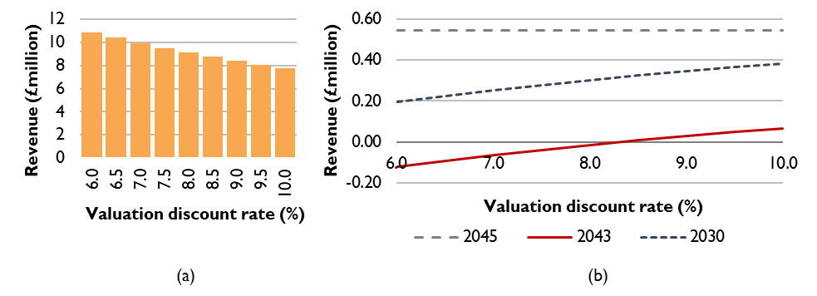
Figure 2: The impact of the valuation on loan size and annual revenue. (a) shows the reduction of required loan size as the discount rate used at valuation increases; (b) shows the impact on annual revenue at different stages of operation. The impact comes from changes in the annual debt servicing costs of the public sector loan.

Impact of public sector debt interest rate
The final level of revenue available for SO use is highly sensitive to the terms of any public sector funding, whether provided as a loan or a grant.
- A zero-interest loan of £9.1 million over 20 years requires annual repayments of £460,000.
- Each one percentage point increase in the interest rate increases annual repayments by approximately £40,000 to £60,000 across the range from 0% to 4.5%.
- For example, a 2% interest rate increases annual repayments to around £560,000 (an additional £100,000 compared with a zero-interest loan), while a 4.5% interest rate increases repayments to approximately £701,000 (an additional £245,000).
Higher interest rates materially reduce SO income and, in this example, result in negative operating profit during the period between the end of the CfD and the end of the public sector loan.
By contrast, a public sector grant removes the need for any debt servicing, increasing SO operating profit by £460,000 per year over the first 20 years of the project.

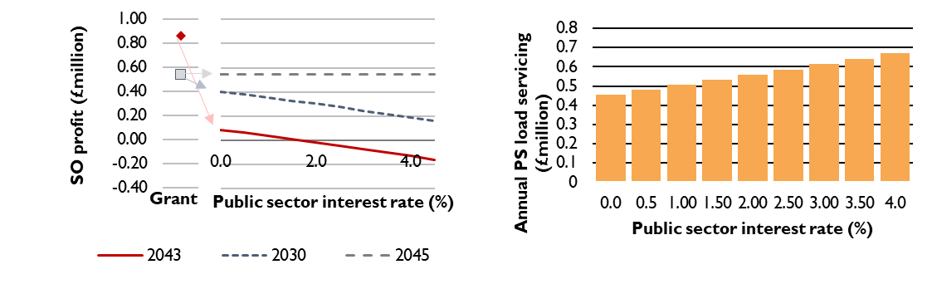
Figure 3: impact of the public sector loan interest rate and a sensitivity where the loan is replaced by a grant. The let hand graph shows the impact on the SO profit after servicing the public sector debt and the right hand graph shows the increase in debt servicing costs as interest rates increase.

Impact of public sector debt tenor
The base case assumes a 20-year repayment period for public sector debt. Extending the repayment period reduces annual debt servicing costs, improving short-term cash flow for the SO organisation. The trade-off is that, unless the loan is interest-free, total lifetime interest payments increase. However, a longer loan tenor can be beneficial in managing the period after the CfD ends, when project margins may be tighter.
For example, extending the loan from 20 years to 30 years reduces annual debt servicing costs by around £150,000 per year, but increases total lifetime repayments by approximately £960,000.
An alternative approach is to shorten the loan tenor so that the debt is fully repaid by the end of the CfD period. This increases annual debt servicing costs by around £150,000 per year relative to the base case and approximately halves the profit available to the SO organisation during the first 15 years of operation. However, it removes the risk of needing to service debt during the early merchant period and results in higher operating profit in later years.
Finally, as shown in the solar example, if a project has an AR7 rather than AR6 CfD, the CfD period lasts 20 rather than 15 years. This could better align certain and higher revenues with the public sector loan period.

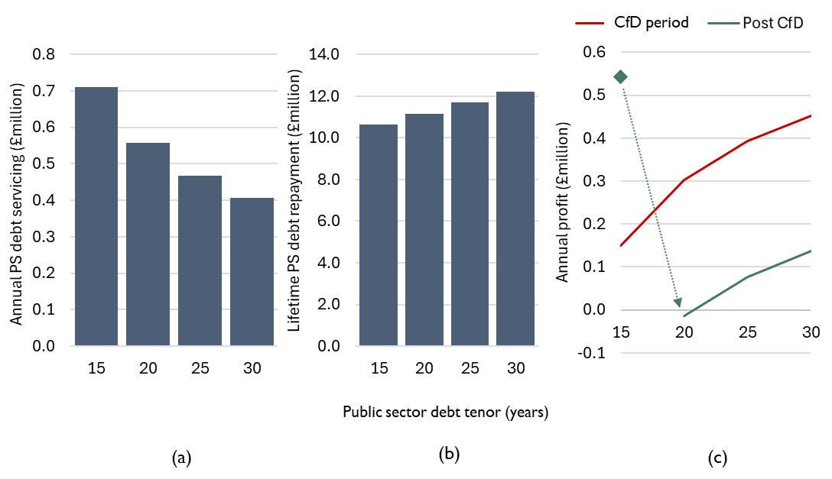
Figure 4: Impact of public sector debt tenor. (a) shows the reduction in annual debt servicing costs as tenor increases; (b) shows the trade off with increasing total debt repayments and (c) shows the impact on usable SO profit during and following the CfD period. Note that in (c) where the tenor is 15 years, the debt is fully paid off before the post-CfD period begins.

Impact of commercial debt interest rate on a project-finance project
When acquiring a stake in an SPV that carries commercial debt, the value of that equity stake is directly influenced by the cost of servicing the debt. These servicing costs are determined by the interest rate charged by the commercial lender, as illustrated in Figure 5.
At present, UK Government bond yields are around 4.5%, meaning that commercial debt is unlikely to be available at rates below approximately 6% and may be higher depending on market conditions and project risk.
Across the range modelled and as shown in Figure 5, each one percentage point increase in the commercial debt interest rate reduces the value of the shared equity stake (20% of project value) by between £410,000 and £490,000.

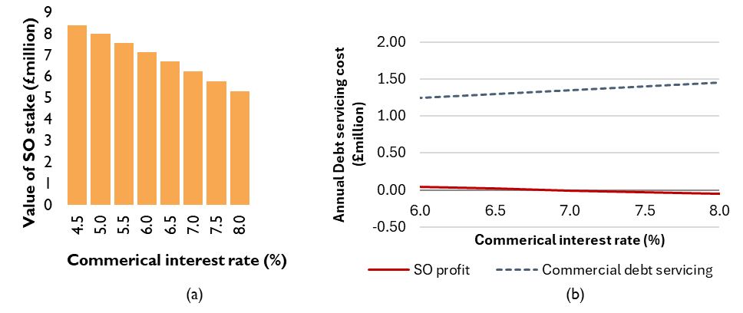
Figure 5: sensitivity to commercial interest rates. (a) shows the impact on the value of 20% share in the SPV and therefore the purchase price for the SO organisation. (b) shows the impact on commercial debt servicing costs to the SO organisation and the final SO profit.

Solar
A similar solar illustration has been modelled to complement the wind examples. Solar projects in Scotland can achieve reasonable load factors, particularly in sunnier areas towards the east coast where annual solar irradiance is highest. Solar projects may also have lower technical risk than wind, as the assets are inherently simpler, with no moving parts, and therefore solar projects can have more predictable maintenance requirements and costs. However, solar projects may offer lower rates of return compared with an equivalent wind projects.
The illustrative solar project is based on a "split project" concept, where physical ownership of the asset is separated out. In this case, the shared ownership (SO) organisation owns specific panels, has its own land rental agreement, and enters into its own operation and maintenance contracts. If it participates pre-construction, the SO organisation would also be party to construction contracts. These could be aligned with those of the majority developer on site.
Split-site projects also entail additional costs to the SO organisation, both upfront and ongoing. Upfront costs may include, for example, the installation of metering infrastructure to enable sharing of the grid connection with the commercial developer, while ongoing costs may arise from the more complex contractual and operational arrangements.
Table 22 sets out the key input assumptions for the project.

Table 22: Input values for the solar example
Parameter | Basecase | Comment
Capacity | 50 MW | Typical of current solar build out projects
Expected load factor | 11% uncurtailed  99% technical availability
CAPEX costs and spending profile | £519 / kW
Grid connection costs | £117 / kW
Annual fixed O&M | £6.13 / kW
Variable O&M | £0 / MWh
TNUoS | £4.60 / kW in 2028 rising to £15.69 /kW in 2033 and remaining constant for the rest of the operating timescale | This is based on expected TNUoS charges for the Southeast Scotland Lothians region and is broadly reflective of the 2023 ‘Ten Year Forecast’ and 2025 ‘five-year forecast from NESO.
CfD price (for years 1 – 20) | £67.30 / MWh (2025 prices) | Reflects A7 clearing prices  Note that AR7 CfDs are 20 years rather than the 15 years offered for previous rounds
Solar capture price for merchant tail period | £54.37 / MWh | 30% discount on projected wholesale prices
Economic curtailment levels | 3% of lifetime output | Reflects an optimistic (low) estimate of economic curtailment
Operational lifetime | 30 years
Additional split site costs (variable) | £11.40 / kW / year | Informed by sector discussions
Additional split site costs (fixed) | £184,000 | Informed by sector discussions

Solar results

Commercial perspective
The overall commercial perspective is less important in this case, as the ownership model – split-site – effectively isolates the SO part of the project from the commercial part. However, in summary, the commercial perspective for a 50 MW wind farm is given in Table 23 and delivers an ungeared IRR of 5.4% over 30 years.
Table 23: Overview of the project-level perspective for the example solar site
Generation capacity | 50 MW
Total capital investment | £30 million
Annual O&M costs | £0.3 million
Annual TNUoS (2030) | £0.23 million
Annual Revenue (CfD period) | £3.5 million

Shared ownership perspective
The results for this scenario initially show positive income to the SO in all years. Note that this example assumes an AR7 CfD. Unlike previous allocation rounds, this provides support for 20 years rather than 15, meaning that the CfD duration and the public sector loan tenor are aligned.
Table 24: Cash flow waterfall for Solar example with split-site project and AR7 CfD.
Values in £million (2025, real, undiscounted) | 2030 |  | 2043 |  | 2048 |  | 2028-58
Upfront stake: £5.4 million
(20% of split-site of a 50 MW site)
Revenue | 0.67 |  | 0.67 |  | 0.54
Operating Costs | 0.20 |  | 0.23 |  | 0.23
Commercial debt servicing | 0.0 |  | 0.0 |  | 0.0
Cash flow from project to SO | 0.51 |  | 0.44 |  | 0.31
Public Sector loan servicing | 0.33 |  | 0.33 |  | 0.0
Final SO income | 0.11 |  | 0.11 |  | 0.31
Cumulative lifetime income  (30 years, undiscounted) |  |  |  |  |  |  |  | 5.3

However, the split-site model incurs a number of additional costs. These include variable costs such as land rental, business rates, insurance, and other operating expenses. They also include fixed costs, such as the cost of arranging initial financing, which can typically exceed £100,000.
The variable elements of these costs add approximately £11/kW to the costs that the SO organisation must cover. In this example, the fixed costs are modelled at £189,000 and are assumed to be funded through an increase in the loan size.
This results in:
- Annual variable SO company costs of approximately £119,000 per year
- Additional debt servicing costs of around £11,000 per year for the duration of the public sector loan
These costs remove the majority of the remaining SO profit shown in Table 18 above, suggesting that this case is unlikely to deliver meaningful net revenue to the SO organisation.

